1. **pwd Command**

**pwd** prints the full path of the current working directory.

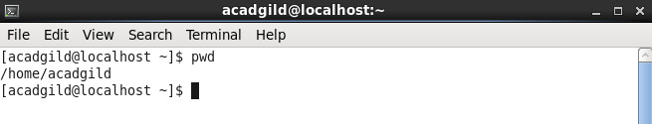

2. **vi command**

**vi** is actually the command which starts the visual mode of **ex**, the landmark editing program developed by Joy. As **ex** gained popularity, Joy noticed that most users were exclusively using its visual mode, so to make things more convenient for his users, he added a link to **ex** which started it in visual mode automatically. Today **vi** is the most popular text editor among Linux users.

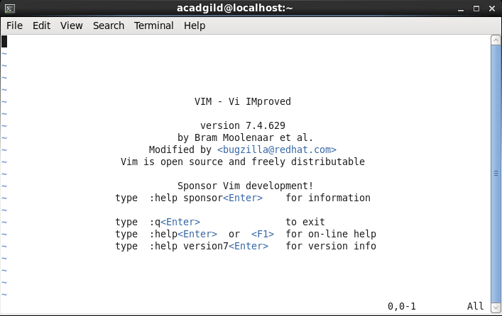

3. **touch command**

The **touch** command updates the access and modification times of each FILE to the current system time. If you specify a FILE that does not already exist, **touch** creates an empty file with that name.If the FILE argument is a dash ("**-**") is handled specially and causes **touch** to change the times of the file associated with standard output.

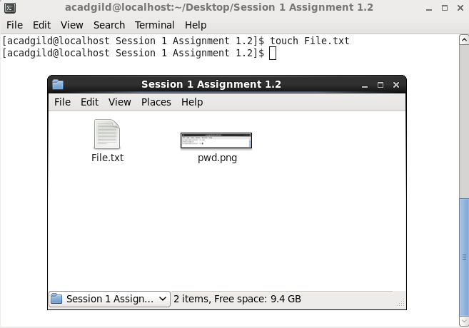

4. **mkdir command**

**mkdir** creates a directory.

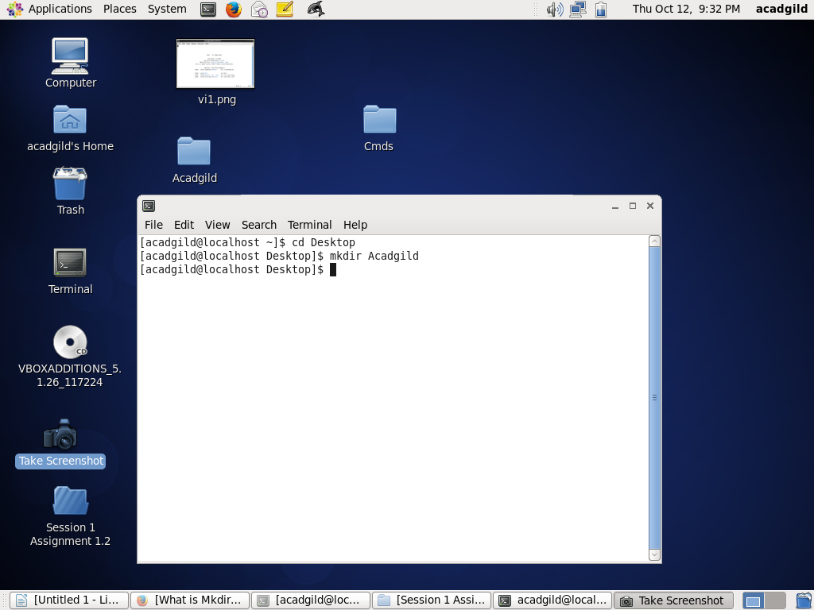

5. **rm command**

**rm** removes each specified *FILE*. By default, it does not remove directories.

Before rm command execution

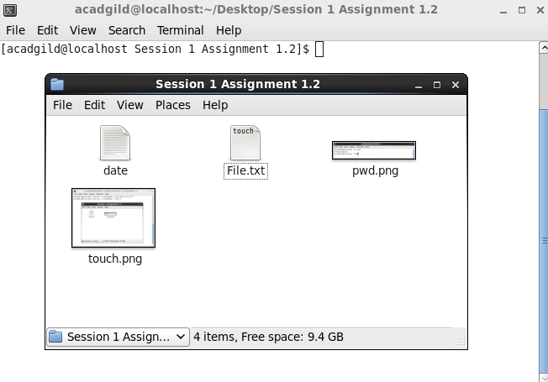

After rm command execution

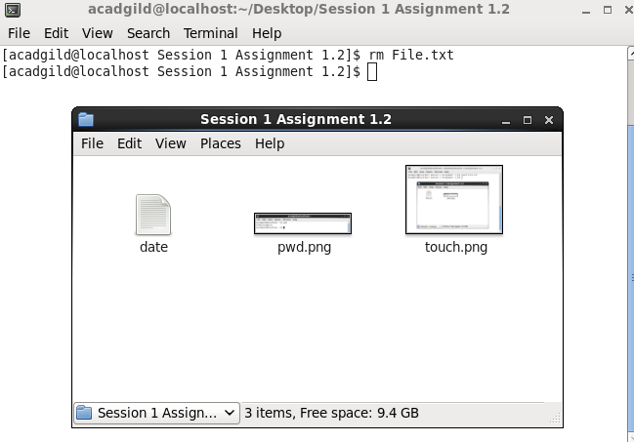

6. **ls command**

List information about the files.

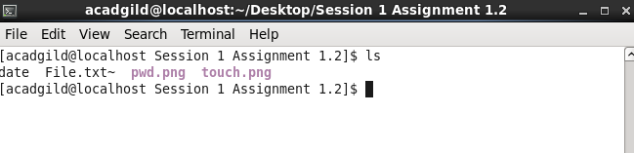

7. **echo command**

**echo** displays a line of text.

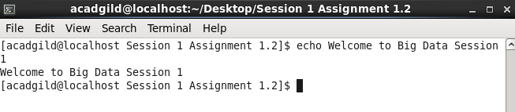

8. **cat command**

**cat** stands for "catenate." It reads data from files, and outputs their contents. It is the simplest way to display the contents of a file at the command line.

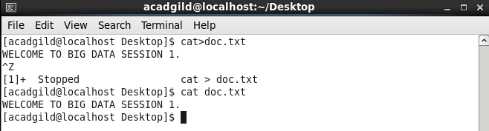

**9. who command**

The **who** command prints information about all users who are currently logged in.

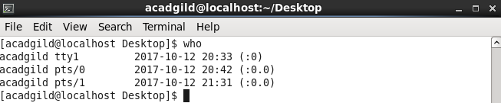

**10. cd command**

The **cd** command is one of the commands you will use the most at the command line in Linux. It allows you to change your working directory. You use it to move around within the hierarchy of your file system.

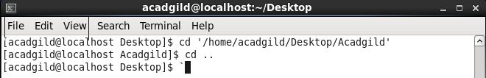

**11. date command**

The **date** command is used to print out, or change the value of, the system's time and date information.

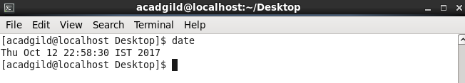

**12. cal command**

**cal** Display a conveniently-formatted calendar from the command line.

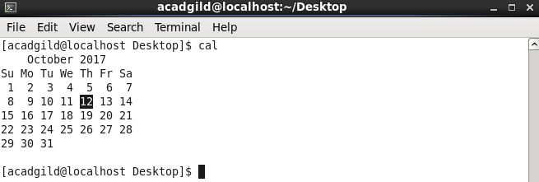

**13. mv command**

**mv** renames file *SOURCE* to *DEST*, or moves the *SOURCE* file (or files) to *DIRECTORY*.

Before mv command

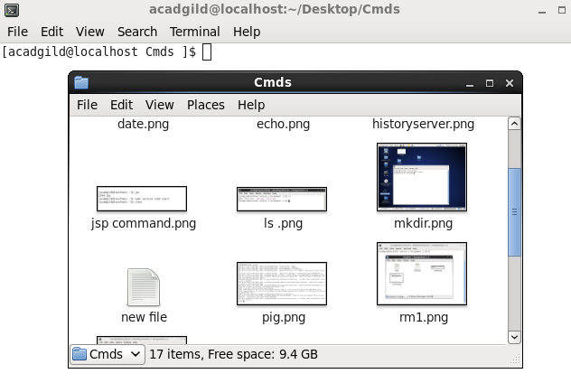

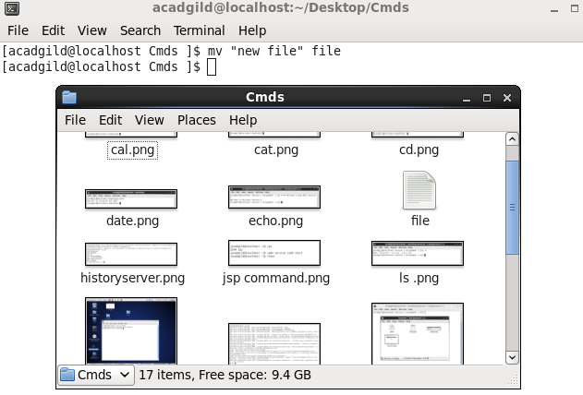

mv command to move file from one directory to another

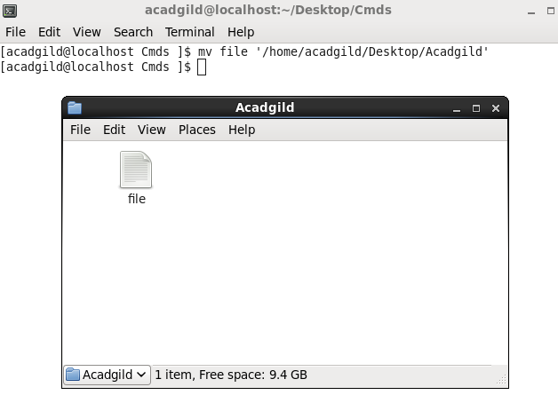

**14. cp command**

The **cp** command is used to make copies of files and directories.

Before copying the file from one directory to another.

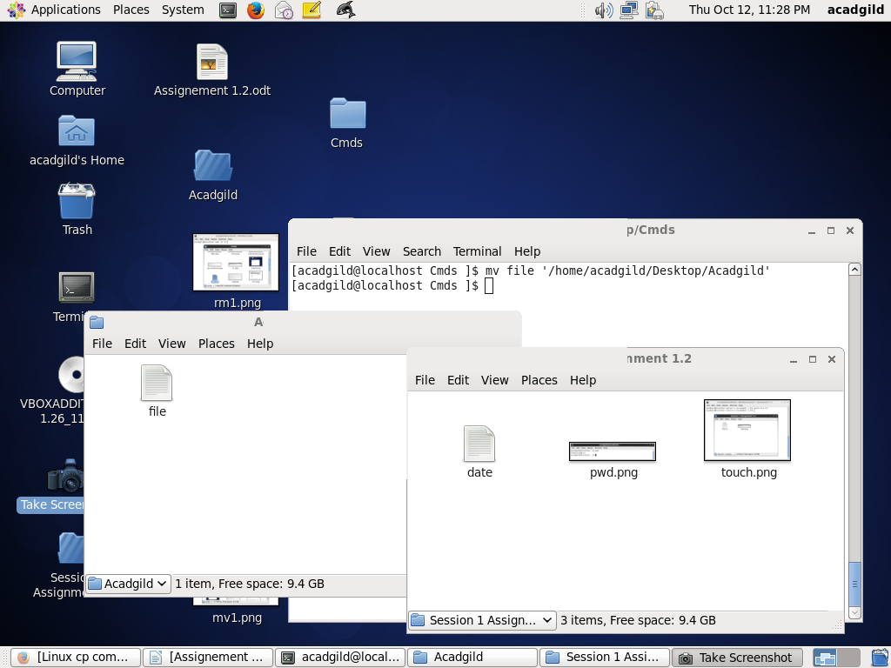

After copying file from one directory to another

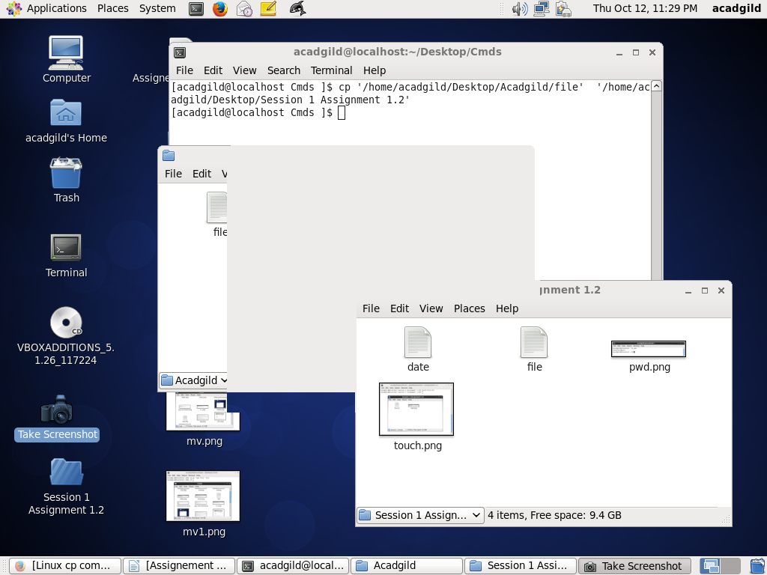

**15. which command**

**which** returns the path names of the files which would be executed in the current environment, had the *filename/s* been given as a command (or commands) in a strictly POSIX-conformant shell. It does this by searching the paths in the **PATH** environment variable for executable files matching the names of the arguments.

